 | EUROPEAN COMMISSION  DIRECTORATE-GENERAL  INFORMATICS  Information Systems Directorate

European Commission
CIPADMIN Use Case Specification:
UC0150 - e-TrustEx Admin Console - Show System Information

Date: | 20/01/2017
Version: | 1.001
Authors: | Anamaria BATRINU
Revised by: | Olivier DERVEAU
Approved by:
Public:
Reference Number:
TABLE OF CONTENTS
1. Use-Case Description 4
1.1. Primary Actor 4
1.2. Definitions, Acronyms and Abbreviations 4
1.3. References 4
1.4. Context Diagram 5
1.4.1. CIPA Administration Console 5
1.4.2. Show System Information module 6
2. Flow of events 6
2.1. Basic Flow 6
2.1.1. User wants to view system information 6
2.1.2. System displays the "System Information" page 6
2.1.3. User visualises system information 6
2.1.4. Use case ends. 6
2.2. Exceptional Flows 6
2.2.1. E1: at steps 2.1.1 User is not authorized for the operation 7
2.2.2. E2: at any step, a technical error occurs 7
3. Special Requirements 7
3.1. Interface(s) with other Systems 7
3.2. Security Requirements 7
3.3. Other Special Requirement 7
4. Preconditions 7
5. Post conditions 7
6. Additional Information 7
6.1. Includes 7
6.2. Extends 7
7. Mock-up screens 8
7.1. System Information page 8

Document History

Version | Date | Comment | Modified Pages
1.000 | 11/05/2015 | First version | All
1.001 | 20/01/2017 | Removed menu details from the mockup screen

Use-Case Description
This use case depicts the sequence of actions that a user needs in order to view System Information like when the application was built, server and database information as wel as storage information.
In the remainder of the document the CIPADMIN application will be referred to as the System.

Primary Actor
A human user can access the Show System Information feature via CIPAdmin interface. This feature is accessible for all user roles. For detailed user access rights on each feature option, please see UC 0100 - eTrustEx Admin Console - Authenticate and Authorise User, section 6.3 User Access Rights.
In the remainder of the document, the user will be reffered to as User.

Definitions, Acronyms and Abbreviations
Acronym, Abbreviation or Definition | Explanation
CIPA | Common Infrastructure for Public Administrations
CIPADMIN | CIPA AdminConsole
UC(s) | Use Case(s)

References
Ref. | Reference | Title / description | Version | Date
[R1] | CIPADMIN-VISION | CIPADMIN Vision document | V.61-EN | 18/04/2013

Context Diagram

CIPA Administration Console
The diagram below depicts all the Services available on the CIPA Administration Console for e-TrustEx platform. Depending on the user role, only a subset of those services is exposed on the e-TrustEx Administration Console home page.
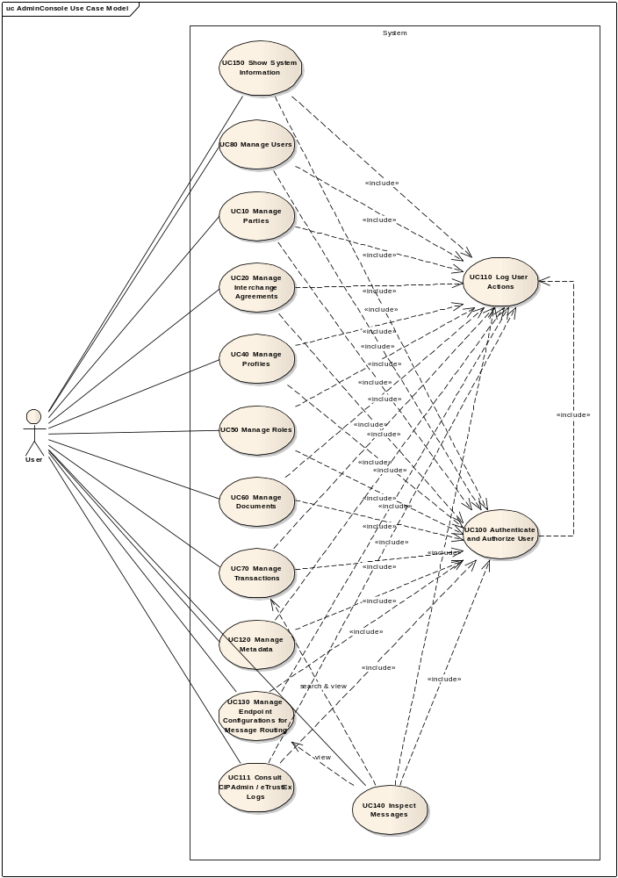

Show System Information module
The diagram below depicts how this use case interacts with other use cases implemented in the Administration Console.
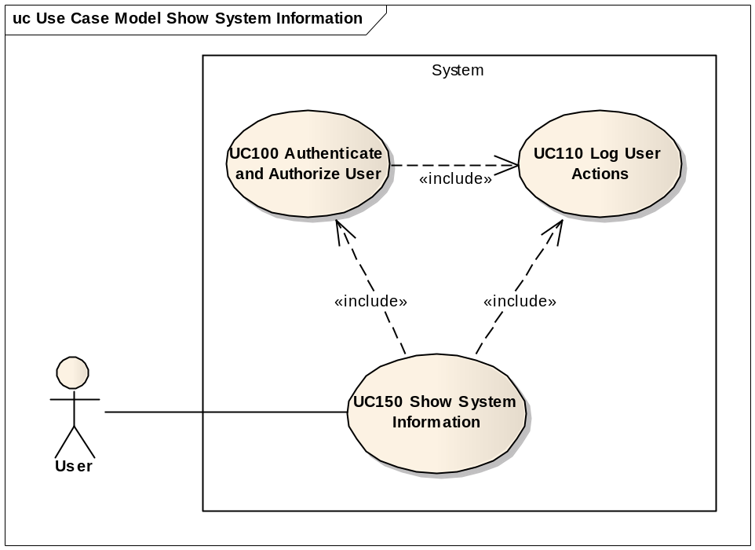

Flow of events

Basic Flow

User wants to view system information
ID | Description
UC150_BR01 | User needs to have the correct access rights in order to access this feature. Please see UC 0100 - eTrustEx Admin Console - Authenticate and Authorise User, section 6.3 User Access Rights for more information.
User selects System Information option from Monitoring and Support menu of the e-TrustEx Administration Console home page.

System displays the "System Information" page
System displays the System Information page as described in paragraph 7.1 System Information page.

User visualises system information

Use case ends.

Exceptional Flows
Any exception happening in the steps pertaining to other use cases that are called in this use case, are managed conform to their respective use case.

E1: at steps 2.1.1 User is not authorized for the operation
Include the steps in section 2.4.1 of Authenticate and Authorise User Use Case.

E2: at any step, a technical error occurs
- System logs the error: include use case Log CIPAdmin User Actions
- System displays a Technical Error containing an error message and the log correlation id from step (1), and also the CIPAdmin email contact to use for further assistance:
"A technical error has occured. If error persists, please contact our CIPAdmin support team at DIGIT-CIPA-SUPPORT@ec.europa.eu and provide all relevant information, including the following correlation id: correlation_id_from_previous_step"
- Use case ends.

Special Requirements

Interface(s) with other Systems

Security Requirements

Other Special Requirement

Preconditions
- User must be registered user of CIPAdmin tool
- User must be logged in & successfully authenticated on the e-TrustEx Admin Console (see Authenticate and Authorise User Use Case)

Post conditions
- [Success] User successfully visualizes the system's information.
- [Failure] The System logs the failure reason and the context, the use case is aborted and the primary actor has been notified of the reasons.

Additional Information

Includes
- For operation authorization: UC 0100 - eTrustEx Admin Console - Authenticate and Authorise User
- For logging: UC 0110 - eTrustEx Admin Console - Log CIPAdmin User Actions

Extends

Mock-up screens

System Information page
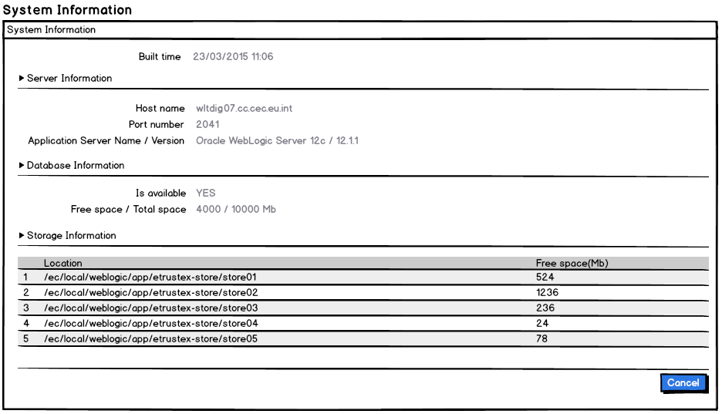
The information that is provided to the user is
- The application built time (date and hour in the format dd/mm/yyyy hh:mm)
- Server information
  - The host name
  - The port number
  - The application server name
  - The application server version
- Database information
  - Availability status
  - Free space and total space in MB
- Storage information (hint: the storage is configured in the system's metadata under the FILE_STORE_PATH key which can contain more than one file stores separated by comma)
  - File store location
  - File store free space
- If certain information is not available, the corresponding label is displayed but no value will be shown next to it

